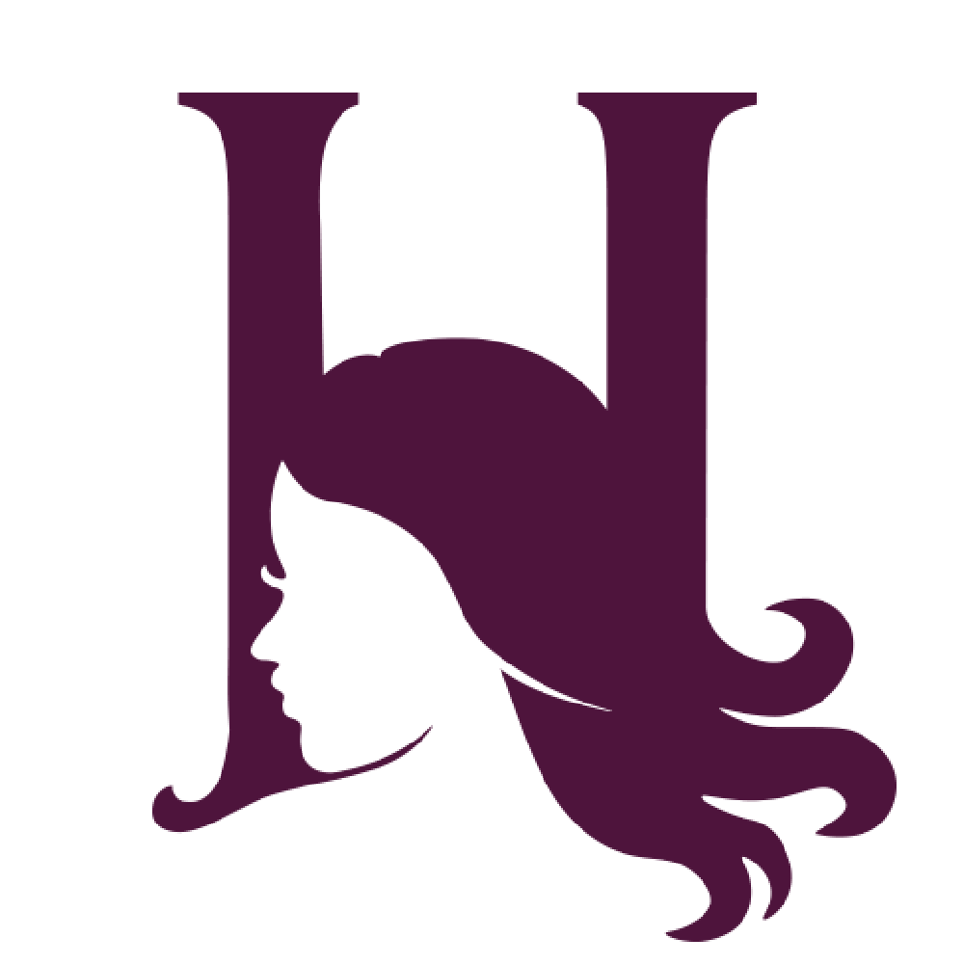
Make-Up

Base & Foundation £20
Eyes £15
Eyes with Strip Lash £20
Soft Glam £35
Full Glam £40
Brow Tidy with Tint £10
Make Up Trial (2Hr) £55
Strip Lash £7
Cluster Lashes £15

Hair
Straightened £10
Curled £15
Pin Curled £20
Blow Dry £25
Blow Dry with Pin Curls £35
Hair Up from £35
Hair Trial (2Hr) £55
Dress Lacing & Styling £10

Bridal Packages
Hair Or Makeup with Trial - Full Bridal Hair Or Makeup includes trial
£100
Hair & Makeup with Trial - Full Bridal Hair & Makeup includes trial
£180
Hair & Makeup with Trial & Dress Lacing - Full Bridal Hair and Makeup including trial and dress lacing
£190
Bridesmaid Packages
Bridesmaid Hair & Makeup - Full Bridesmaid Hair & Makeup
£80
Bridesmaid Hair & Makeup with Trial - Full Bridesmaid Hair & Makeup includes trial
£120
Prom Packages
Hair & Makeup -Hair & Makeup for Prom
£80
Hair & Makeup with trial -Hair & Makeup for Prom with trial
£120

